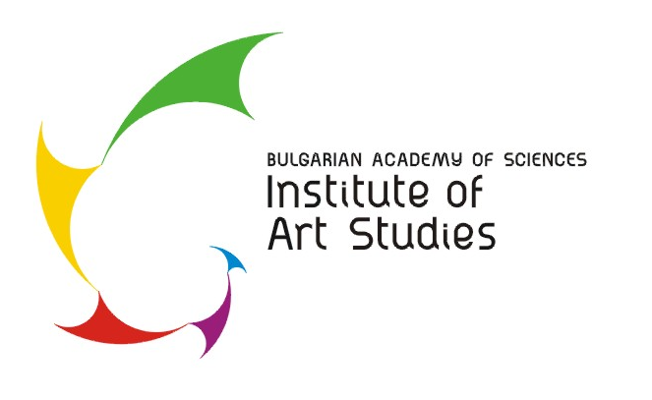 | Krakra Str. 21  1504Sofia  tel. +359 2 944 2414, +359 2 489 0357,  +359 2 489 0358, +359 2 489 0094,  +359 2 489 0095  fax + 359 2 943 3092  e-mail: office@artstudies.bg

ART READINGS 2017
New Art Module
Crossing Borders in Arts: beyond Modern & Postmodern

CONFERENCE REGISTRATION FORM

Name:
Title:
Organization:
Conference Section:  (please, mark the relevant) | Fine Arts * Music * Theater * Cinema * Architecture  Other: . . . . . . . . . . . . . . . . . . . (please, specify)
Paper Title:

Short CV (up to 600 characters, with spaces)
E-mail:
Phone:
Key words:

Abstract (no more than 900 characters, with spaces):

Please send back the registration form no later than 1.09.2016 to:
infoartstudies@gmail.com

